**Conductor in a Magnetic Field—The Motor Principle**

Electric motors are used in cooling fans for computers, in refrigerators, in electric cars, in power tools such as electric drills, and even in many remote-controlled toys. Many subway systems use electric motors as a clean and silent way to power their trains. But what do electric motors have to do with magnetic fields?

In 1821, following Oersted’s discovery of electromagnetism, English physicist Michael Faraday (1791–1867) set out to prove that, as a wire carrying electric current could cause a magnetized compass needle to move, so in reverse a magnet could cause a current-carrying wire to move. Suspending a piece of wire above a bowl of mercury in which he had fixed a magnet upright, Faraday connected the wire to a battery, and the wire began to rotate.

Faraday determined that the magnetic field of a permanent magnet can exert a force on the charges in a current-carrying conductor. **Figure 1** shows how the direction of this force is related to the magnetic field of the conductor and to the external magnetic field.

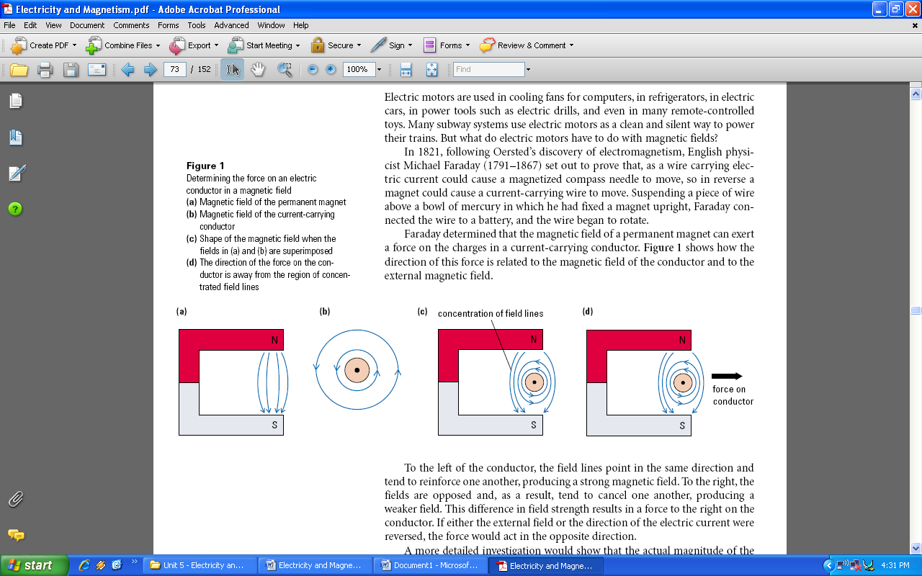

To the left of the conductor, the field lines point in the same direction and tend to reinforce one another, producing a strong magnetic field. To the right, the fields are opposed and, as a result, tend to cancel one another, producing a weaker field. This difference in field strength results in a force to the right on the conductor. If either the external field or the direction of the electric current were reversed, the force would act in the opposite direction.

A more detailed investigation would show that the actual magnitude of the force depends on the magnitude of both the current and the magnetic field. These effects are summarized in the **motor principle**

**Motor Principle**

A current-carrying conductor that cuts across external magnetic field lines experiences a force perpendicular to both the magnetic field and the direction of electric current. The magnitude of this force depends on the magnitude of both the external field and the current, as well as the angle between the conductor and the magnetic field it cuts across.

The direction of the force on the conductor depends on the direction of electric current and the direction of the external magnetic field (**Figure 2**). The direction of the force can be determined using what is called the **right-hand rule for the motor principle**.

**Right-Hand Rule for the Motor Principle**

If the fingers of the open right hand point in the direction of the external magnetic field, and the thumb represents the direction of electric current, the force on the conductor will be in the direction in which the right palm faces.

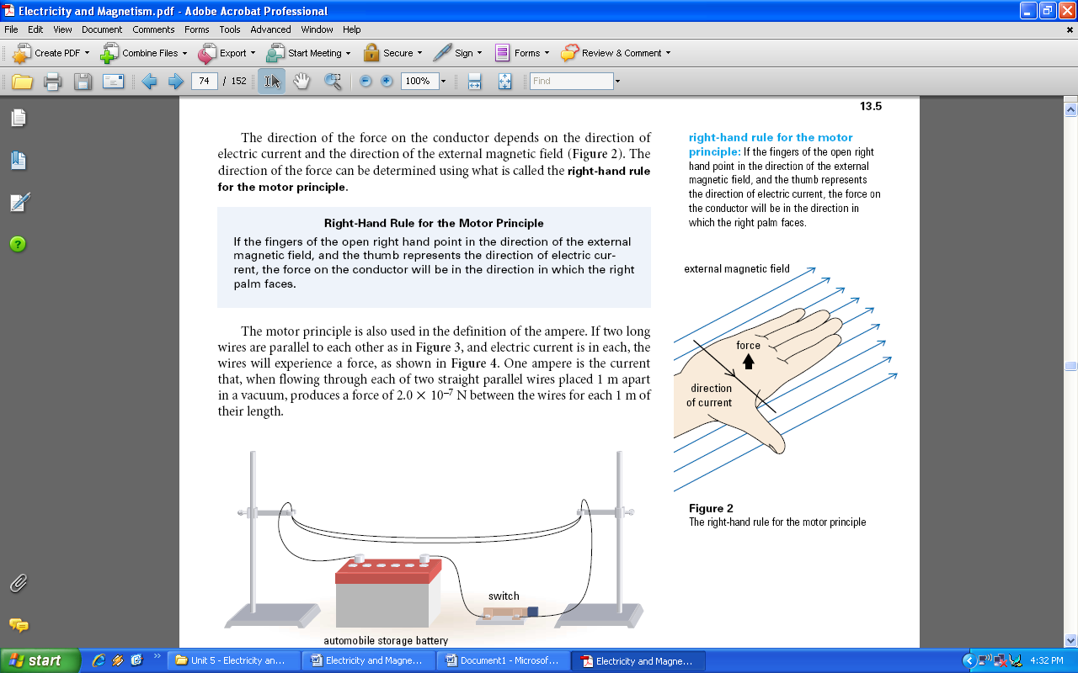

The motor principle is also used in the definition of the ampere. If two long wires are parallel to each other as in **Figure 3**, and electric current is in each, the wires will experience a force, as shown in **Figure 4**. One ampere is the current that, when flowing through each of two straight parallel wires placed 1 m apart in a vacuum, produces a force of 2.0 _ 10–7 N between the wires for each 1 m of their length.

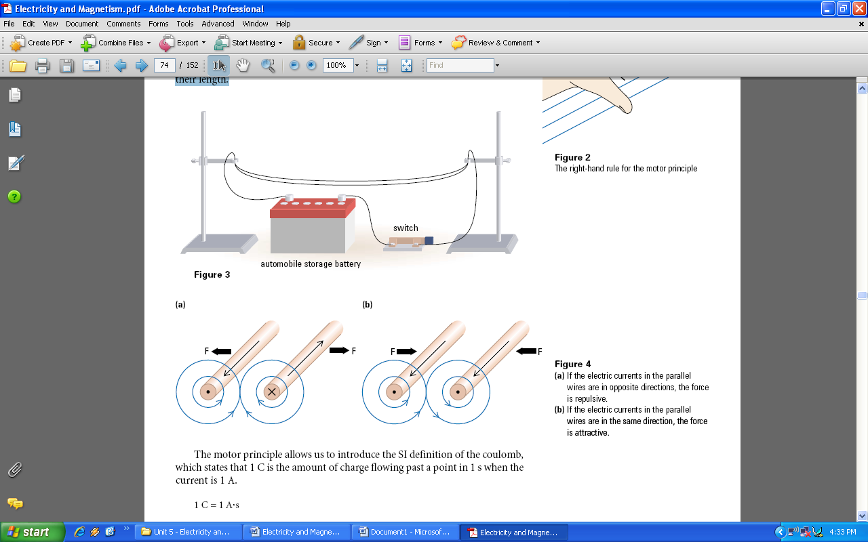

**Activity - Motor Principle**

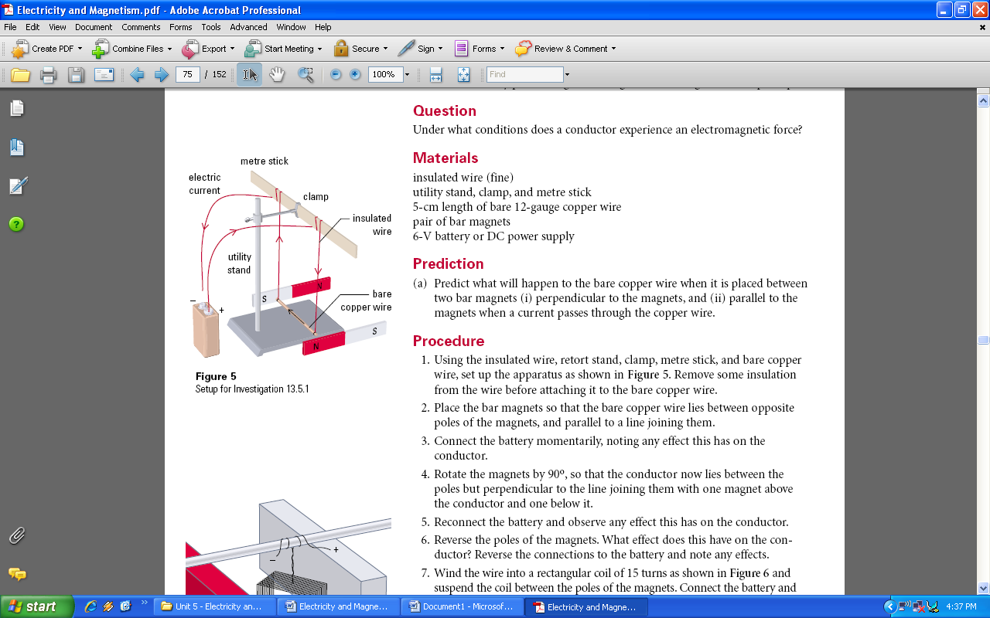

Predict what will happen to the bare copper wire when it is placed between two bar magnets (i) perpendicular to the magnets, and (ii) parallel to the magnets when a current passes through the copper wire.

1. Using the insulated wire, retort stand, clamp, metre stick, and bare copper wire, set up the apparatus as shown in **Figure 5**. Remove some insulation from the wire before attaching it to the bare copper wire.
2. Place the bar magnets so that the bare copper wire lies between opposite poles of the magnets, and parallel to a line joining them.
3. Connect the battery momentarily, noting any effect this has on the conductor.
4. Rotate the magnets by 90o, so that the conductor now lies between the poles but perpendicular to the line joining them with one magnet above the conductor and one below it.
5. Reconnect the battery and observe any effect this has on the conductor.
6. Reverse the poles of the magnets. What effect does this have on the conductor?
7. Reverse the connections to the battery and note any effects.

